Inheritance, Specificity and Selectors

What is Inheritance
Inheritance is an essential concept in the world of programming and web development. It helps in making code efficient, organized, and easy to maintain.
In programming, inheritance refers to the ability of one class or object to inherit properties and methods from another class or object. This principle helps in reusing code, making it more organized and easier to maintain.
In the context of CSS, inheritance is the process by which certain style properties of an HTML element are passed down to its descendants, i.e., child elements. This means that if you apply a certain style property to a parent element, the child elements will inherit that property automatically, unless they have a specific style property defined for themselves.
Inheritance in CSS is a powerful concept that helps in reducing the amount of code you need to write, making it more efficient and easier to maintain.

How does Inheritance work in CSS?
In CSS, inheritance works by passing down specific style property values from a parent element to its child elements. Not all CSS properties are inherited by default. Some properties, like color and font-family, are inherited automatically, while others require explicit inheritance using the inherit keyword.
Here's an example to illustrate the concept of inheritance in CSS:
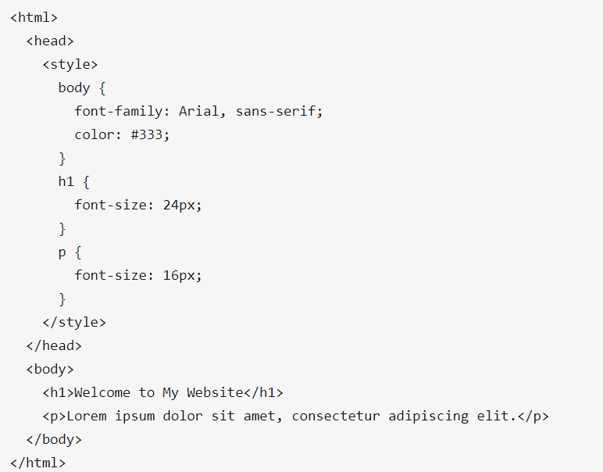

In this example, we have defined a font family and color for the body element. These properties will be inherited by all the child elements of the body, including the h1 and p tags. So, both the heading and the paragraph will have Arial as the font and a color value of #333.

Using the inherit keyword
As mentioned earlier, not all CSS properties are inherited automatically. You can explicitly set a property to inherit its value from the parent element using the inherit keyword. Let's look at an example:
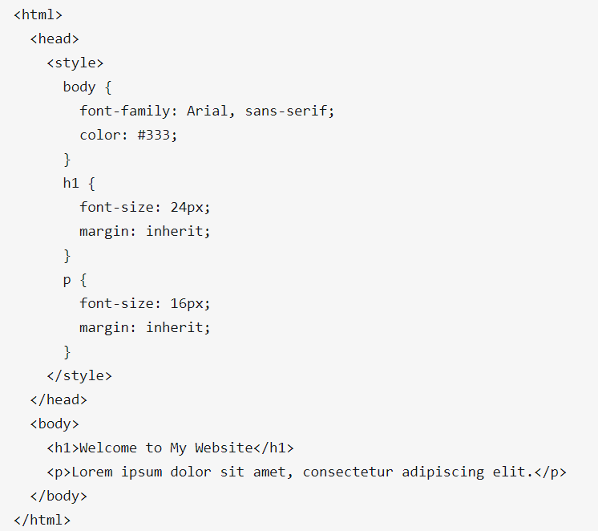
In this example, we have added the margin property to the h1 and p tags with the value inherit. This means that the margin of these elements will be inherited from their parent element, which is the body element in this case.

Understanding the Cascade
Inheritance in CSS is closely related to another important concept known as the cascade. The cascade is the process by which CSS determines which style rules should be applied to an element when there are multiple rules targeting it.
The cascade works by following a set of rules to determine the specificity of a selector. The more specific a selector is, the higher priority it has when determining which styles should be applied to an element. In the case of inheritance, if a child element has a style property explicitly defined for itself, it will override the inherited value from the parent element.
Let's look at an example to understand the cascade in action:
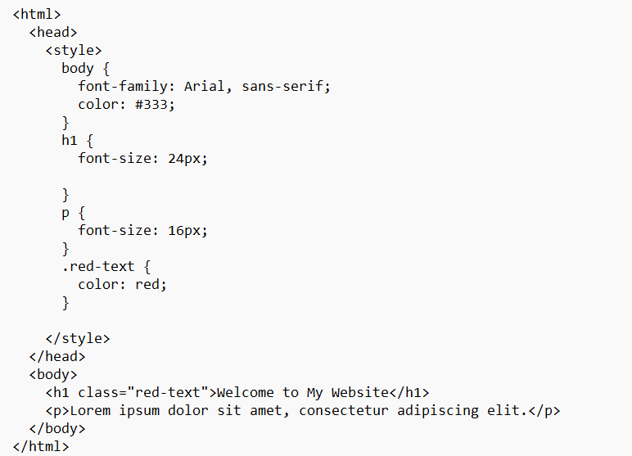
In this example, we have added a class called .red-text that sets the text color to red. We have also applied this class to the h1 tag. Since the .red-text selector is more specific than the h1 selector, the text color of the heading will be red instead of the inherited value of #333.

Inheritance vs. Specificity
It's essential to understand the difference between inheritance and specificity in CSS. While inheritance deals with passing down style properties from a parent element to its child elements, specificity determines which style rules should be applied to an element in case of conflicting style declarations.
In short, inheritance is about sharing styles between parent and child elements, while specificity is about resolving conflicts between competing style declarations.

Specificity
Specificity is an algorithm that calculates the weight that is applied to a given CSS declaration.

Specificity Hierarchy
Every CSS selector has its place in the specificity hierarchy.
There are four categories which define the specificity level of a selector:
- Inline styles - Example: <h1 style="color: pink;">
- IDs - Example: #navbar
- Classes, pseudo-classes, attribute selectors - Example: .test, :hover, [href]
- Elements and pseudo-elements - Example: h1, ::before

How to Calculate Specificity?
Start at 0, add 100 for each ID value, add 10 for each class value (or pseudo-class or attribute selector), add 1 for each element selector or pseudo-element.
Note 1: Inline style gets a specificity value of 1000 and is always given the highest priority!
Note 2: There is one exception to this rule: if you use the !important rule, it will even override inline styles!
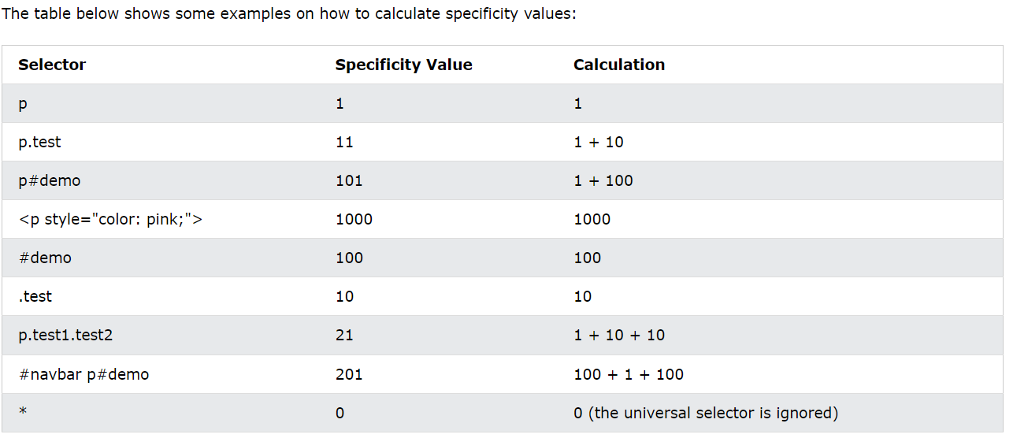
Example
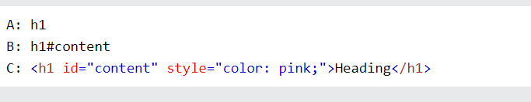
The specificity of A is 1 (one element selector)
The specificity of B is 101 (one ID reference + one element selector)
The specificity of C is 1000 (inline styling)
Since the third rule (C) has the highest specificity value (1000), this style declaration will be applied.

Equal specificity: the latest rule wins - If the same rule is written twice into the external style sheet, then the latest rule wins:
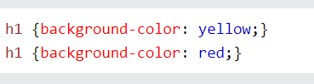

ID selectors have a higher specificity than attribute selectors - Look at the following three code lines: The first rule is more specific than the other two and will therefore be applied.
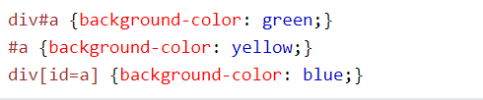

Contextual selectors are more specific than a single element selector - The embedded style sheet is closer to the element to be styled. So, in the following situation the latter rule will be applied.
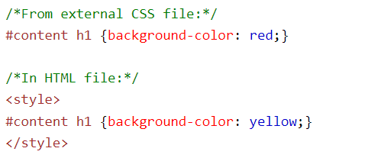

A class selector beats any number of element selectors - a class selector such as .intro beats h1, p, div, etc:
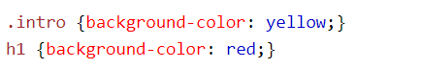

The universal selector (*) and inherited values have a specificity of 0 - The universal selector (*) and inherited values are ignored!

Conclusion on inheritance and specificity
To recap, inheritance is the process by which certain style properties of an HTML element are passed down to its descendants. The inherit keyword can be used to explicitly set a property to inherit its value from the parent element. Finally, the cascade and specificity are important concepts related to inheritance that help determine which style rules should be applied to an element when there are multiple rules targeting it.

What are Selectors?
Selectors are the foundation of CSS. They help us target specific elements or groups of elements on a webpage, so that we can apply styles to them. The different types of selectors available in CSS are:
- Element Selector
- Class Selector
- ID Selector
- Combinators
  - Descendant Combinator
  - Child Combinator
  - Adjacent Sibling Combinator
  - General Sibling Combinator
- Pseudo-classes and Pseudo-elements
- Pseudo-classes
- Pseudo-elements

Child Combinator
A child combinator targets elements that are direct children of a specific element. In CSS, we denote a child combinator by a greater-than sign > between two selectors.
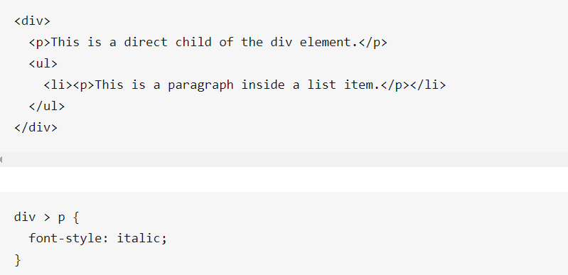
In this example, only the paragraph that is a direct child of the div element will have an italic font style. The paragraph inside the list item will remain unaffected.

Adjacent Sibling Combinator
An adjacent sibling combinator targets elements that are immediate siblings of a specific element. In CSS, we denote an adjacent sibling combinator by a plus sign + between two selectors.
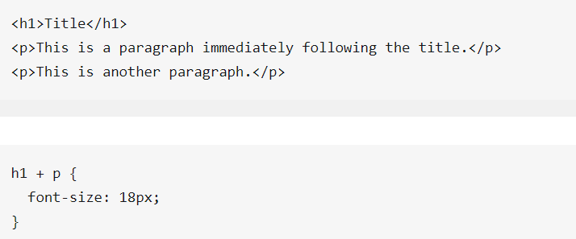
In this example, only the paragraph immediately following the h1 element will have a font size of 18 pixels. The other paragraph will remain unaffected.

General Sibling Combinator
A general sibling combinator targets elements that are siblings of a specific element. In CSS, we denote a general sibling combinator by a tilde ~ between two selectors.
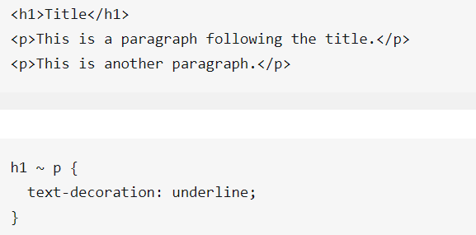

In this example, both paragraphs following the h1 element will have an underline text decoration.

Pseudo-classes and Pseudo-elements
Pseudo-classes and pseudo-elements are special selectors that allow you to target elements based on their state or position in the document.

Pseudo-classes
Pseudo-classes target elements based on their state, such as when a button is being hovered over or an input field has focus. Some common pseudo-classes include :hover, :active, :focus, and :nth-child.
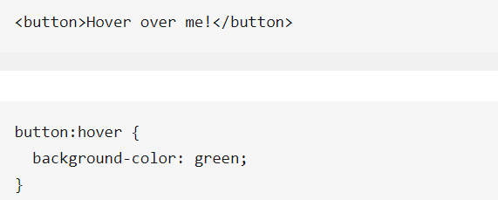

In this example, the button's background color will change to green when the user hovers over it.

Pseudo-elements
Pseudo-elements target specific parts of an element, such as the first letter or before/after the content. Some common pseudo-elements include ::first-letter, ::before, and ::after.
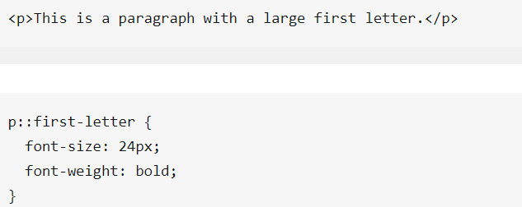
In this example, the first letter of the paragraph will have a font size of 24 pixels and the text will be bold.

The ::after pseudo-element can be used to insert some content after the content of an element.
The following example inserts an image after the content of each <h1> element:
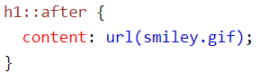

References
https://www.altcademy.com/blog/what-is-inheritance-in-css/
w3schools

